**DEVELOP WEB APPLICATION USING NODE-RED**

|  |  |
| --- | --- |
| Team ID | PNT2022TMID17521 |
| Project Name | Smart Solutions For Railways |

**PROCEDURE:**

**Step1**: Develop node red application

**Step2**: Install the required nodes from manage palette option

**Step3**: Connect the node flow

**Step4**: Deploy the flow

**WEB APPLICATION :**

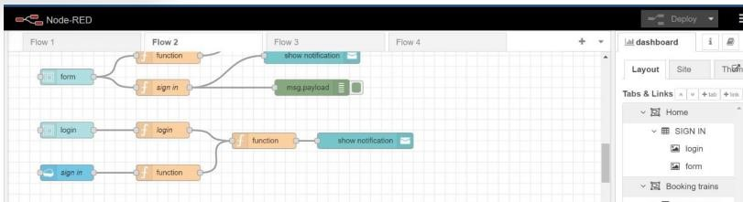

**NODES TO BOOK TRAIN:**

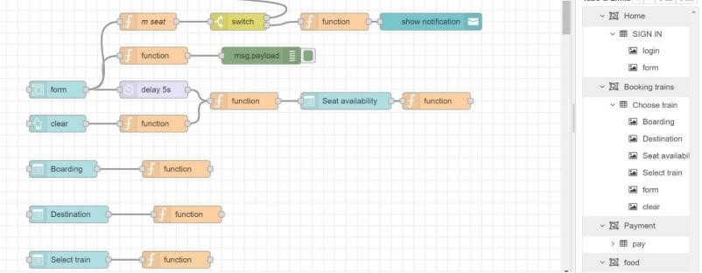

**WEBPAGE FOR TRAIN BOOKING:**

**STEP – 1:**

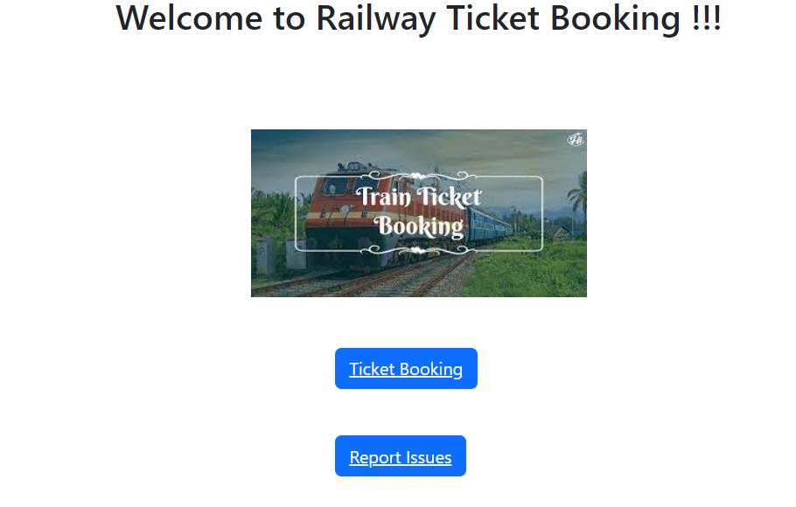

**STEP – 2:**

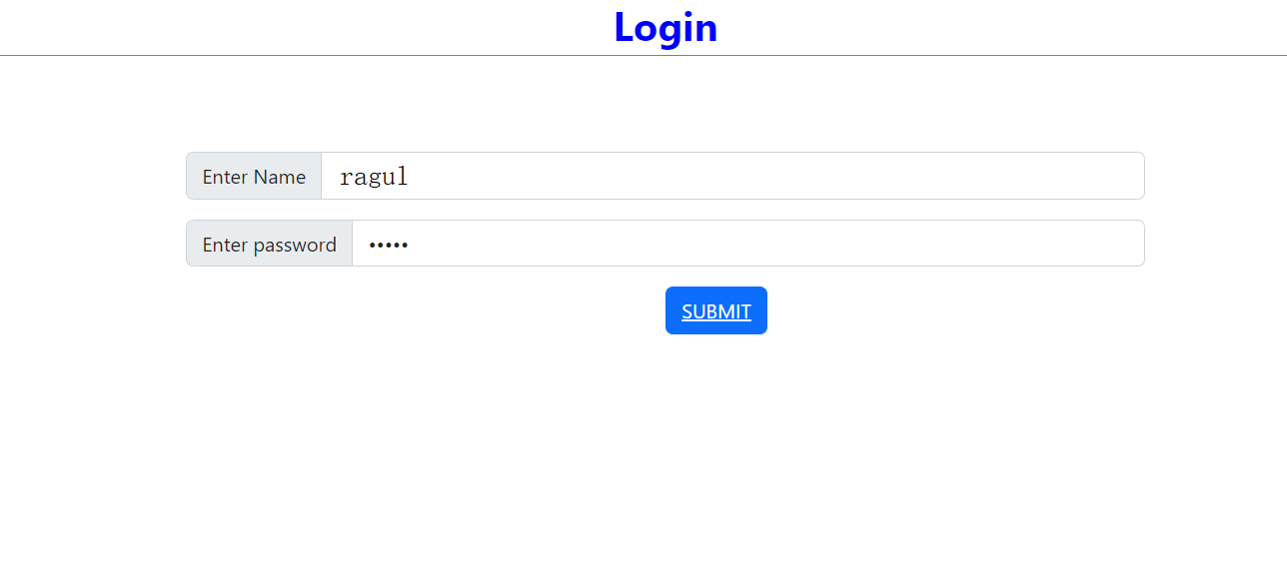

**STEP -3:**

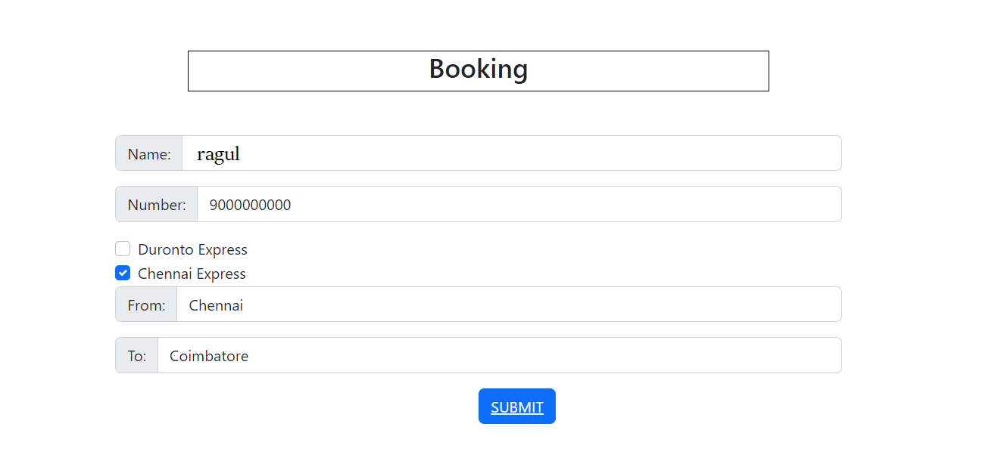

**STEP – 4: (AFTER DOING PAYMETS FOLLOWING WEBPAGE WILL BE DISPLAYED)**

